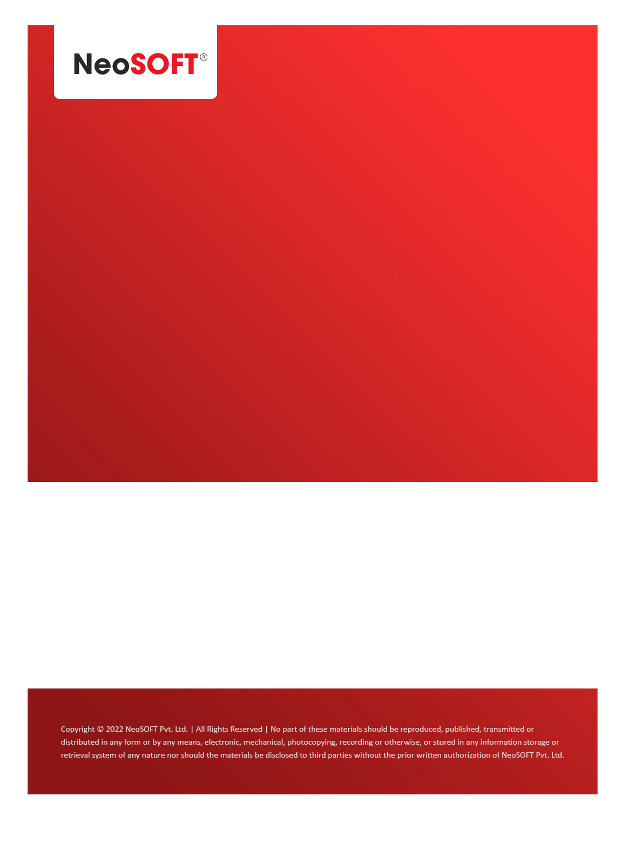`

**Eltizam MOM – Wireframes review and Questions**

Eltizam

Client Name

NeoSOFT is a SEI-CMMI Level-5 Global IT Consulting & Software Solutions Provider

**May 12,** 2023

|  |  |
| --- | --- |
| **Meeting Date, Time, and Attendee Details** | |
| **Date** | 12th May 2023 |
| **Venue** | MS Teams |
| **Time** | 04.30 PM – 05.00 PM IST |
| **Meeting Type** | Wireframes review, Project status |
| **Internal Attendees** | * YallaReddy * Akshata Shinde |
| **Client Attendees** | * Karuna Pawar |
| **Presented By** |  |
| **MOM Prepared By** | * YallaReddy |

|  |  |
| --- | --- |
| **Details of Meeting** | |
| **Sr. No.** | **Description** |
| 1 | Discussed completed wireframes for Evaluation process module and reviewed them with Karuna with 2 open questions. |
| 2 | All latest wireframe changes are deployed link and waiting for the review feedback from team. |
| 3 | Waiting from Karuna to get information on   * Evaluation Assessment form * Invoice receipt * Payment receipt details. |
| 4 | Requested status call with Vinod via Karuna to explain current status, timeline effected areas in future because of current slight delay in progress. |
| 5 |  |

|  |  |  |  |  |  |
| --- | --- | --- | --- | --- | --- |
| **Actionable** | | | | | |
| **Sr. No.** | **Action Item** | **Assigned to** | **Assigned Date** | **Expected Completion Date** | **Status** |
| 1 |  |  |  |  |  |
|  |  |  |  |  |  |
|  |  |  |  |  |  |